I tried to make system have it’s self diagnostic system which will facilitate error checking and detecting what part have a problem .

So I added memory check system , so that if memory have an error the system will detect that the error is in the memory;

Try to disconnect the memory and the system will detect the error automatically .

I have some ideas to self diagnostic like getting feedback from the motor using U-sensor or attached potentiometer as position feedback

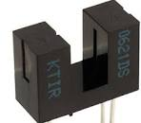

U-sensor